**How To Minimize DFA?**

The two popular methods for minimizing a DFA are-

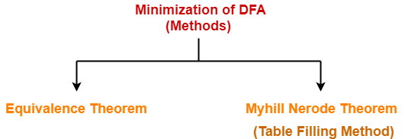

In this article, we will discuss Minimization of DFA Using Equivalence Theorem.

**Minimization of DFA Using Equivalence Theorem-**

**Step-01:**

Eliminate all the dead states and inaccessible states from the given DFA (if any).

| **Dead State**    All those non-final states which transit to itself for all input symbols in ∑ are called as dead states.    **Inaccessible State**    All those states which can never be reached from the initial state are called as inaccessible states. |
| --- |

**Step-02:**

* Draw a state transition table for the given DFA.
* Transition table shows the transition of all states on all input symbols in Σ.

**Step-03:**

Now, start applying equivalence theorem.

* Take a counter variable k and initialize it with value 0.
* Divide Q (set of states) into two sets such that one set contains all the non-final states and other set contains all the final states.
* This partition is called P0.

**Step-04:**

* Increment k by 1.
* Find Pk by partitioning the different sets of Pk-1 .
* In each set of Pk-1 , consider all the possible pair of states within each set and if the two states are distinguishable, partition the set into different sets in Pk.

| Two states q1 and q2 are distinguishable in partition Pk for any input symbol ‘a’,  if δ (q1, a) and δ (q2, a) are in different sets in partition Pk-1. |
| --- |

**Step-05:**

* Repeat step-04 until no change in partition occurs.
* In other words, when you find Pk = Pk-1, stop.

**Step-06:**

* All those states which belong to the same set are equivalent.
* The equivalent states are merged to form a single state in the minimal DFA.

| **Number of states in Minimal DFA**  **= Number of sets in Pk** |
| --- |

**PRACTICE PROBLEMS BASED ON MINIMIZATION OF DFA-**

**Problem-01:**

Minimize the given DFA-

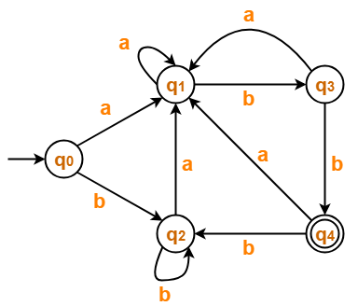

**Solution-**

**Step-01:**

The given DFA contains no dead states and inaccessible states.

**Step-02:**

Draw a state transition table-

|  | **a** | **b** |
| --- | --- | --- |
| →**q0** | q1 | q2 |
| **q1** | q1 | q3 |
| **q2** | q1 | q2 |
| **q3** | q1 | *q4 |
| **\*q4** | q1 | q2 |

**Step-03:**

Now using Equivalence Theorem, we have-

P0 = { q0 , q1 , q2 , q3 } { q4 }

P1 = { q0 , q1 , q2 } { q3 } { q4 }

P2 = { q0 , q2 } { q1 } { q3 } { q4 }

P3 = { q0 , q2 } { q1 } { q3 } { q4 }

Since P3 = P2, so we stop.

From P3, we infer that states q0 and q2 are equivalent and can be merged together.

So, Our minimal DFA is-

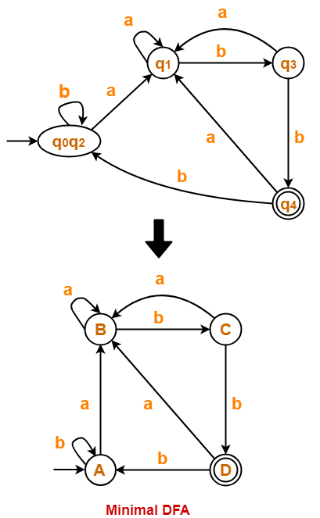

**Problem-02:**

Minimize the given DFA-

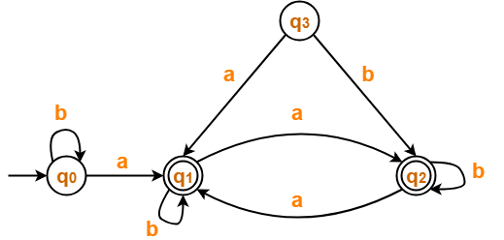

**Solution-**

**Step-01:**

* State q3 is inaccessible from the initial state.
* So, we eliminate it and its associated edges from the DFA.

The resulting DFA is-

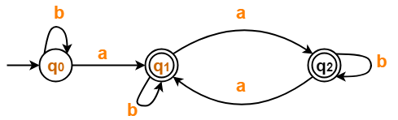

**Step-02:**

Draw a state transition table-

|  | **a** | **b** |
| --- | --- | --- |
| →**q0** | *q1 | q0 |
| **\*q1** | *q2 | *q1 |
| **\*q2** | *q1 | *q2 |

**Step-03:**

Now using Equivalence Theorem, we have-

P0 = { q0 } { q1 , q2 }

P1 = { q0 } { q1 , q2 }

Since P1 = P0, so we stop.

From P1, we infer that states q1 and q2 are equivalent and can be merged together.

So, Our minimal DFA is-

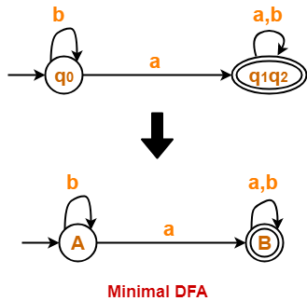

**Problem-03:**

Minimize the given DFA-

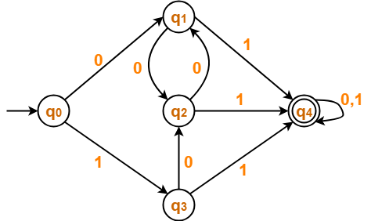

**Solution-**

**Step-01:**

The given DFA contains no dead states and inaccessible states.

**Step-02:**

Draw a state transition table-

|  | **0** | **1** |
| --- | --- | --- |
| →**q0** | q1 | q3 |
| **q1** | q2 | *q4 |
| **q2** | q1 | *q4 |
| **q3** | q2 | *q4 |
| **\*q4** | *q4 | *q4 |

**Step-03:**

Now using Equivalence Theorem, we have-

P0 = { q0 , q1 , q2 , q3 } { q4 }

P1 = { q0 } { q1 , q2 , q3 } { q4 }

P2 = { q0 } { q1 , q2 , q3 } { q4 }

Since P2 = P1, so we stop.

From P2, we infer that states q1 , q2 and q3 are equivalent and can be merged together.

So, Our minimal DFA is-

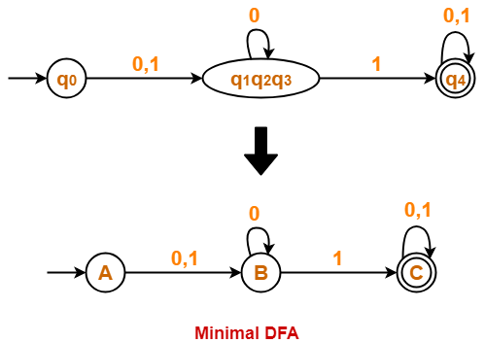

**Problem-04:**

Minimize the given DFA-

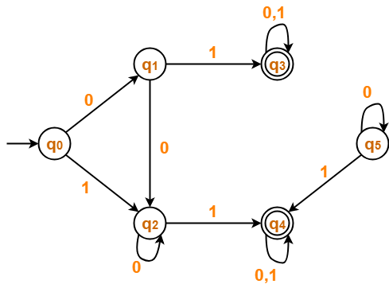

**Solution-**

**Step-01:**

* State q5 is inaccessible from the initial state.
* So, we eliminate it and its associated edges from the DFA.

The resulting DFA is-

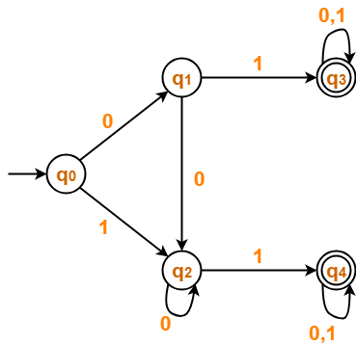

**Step-02:**

Draw a state transition table-

|  | **0** | **1** |
| --- | --- | --- |
| →**q0** | q1 | q2 |
| **q1** | q2 | *q3 |
| **q2** | q2 | *q4 |
| **\*q3** | *q3 | *q3 |
| **\*q4** | *q4 | *q4 |

**Step-03:**

Now using Equivalence Theorem, we have-

P0 = { q0 , q1 , q2 } { q3 , q4 }

P1 = { q0 } { q1 , q2 } { q3 , q4 }

P2 = { q0 } { q1 , q2 } { q3 , q4 }

Since P2 = P1, so we stop.

From P2, we infer-

* States q1 and q2 are equivalent and can be merged together.
* States q3 and q4 are equivalent and can be merged together.

So, Our minimal DFA is-

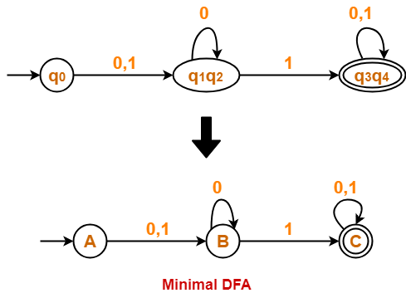

**Also Read-** **[Construction of DFA](https://www.gatevidyalay.com/how-to-solve-dfa-problems-dfa-solved-examples/)**

To gain better understanding about Minimization of DFA,

**[Watch this Video Lecture](https://www.youtube.com/watch?v=1GZOzTJOBuM)**

**Next Article-** **[Converting DFA to Regular Expression](https://www.gatevidyalay.com/dfa-to-regular-expression-examples-automata/)**